Technology – Lighting up the Night
Year (s) 3/4 | Situation/Big Question: Can we create a simple electronic circuit (system) that we can use as a night light? Is an electronic circuit a system? |  | Duration  2-3 weeks
Key Competencies: |  | Values:
Thinking; Using Language, symbols and text, Managing self; Relating to others; Participating and Contributing |  | Excellence; Innovation; Inquiry and Curiosity; Equity; Community and Participation; Ecological sustainability; Integrity; Respect

Level: 1 | Achievement Objectives – Technological Practice
Planning for Practice (PP)
Describe the outcome they are developing and identify the attributes it should have, taking account of the need or opportunity and the resources available.
Brief Development (BD)
Outline a general plan to support the development of an outcome, identifying appropriate steps and resources.
Outcome development and evaluation (ODE)
Investigate a context to communicate potential outcomes. Evaluate these against attributes; select and develop an outcome in keeping with the identified attributes.
Achievement Objectives – Technological Knowledge

Technological modelling (TM)
Understand that functional models are used to represent reality and test design concepts and that prototypes are used to test Technological Outcomes
Technological products (TP)
Understand that technological products are made from materials that have performance properties.
Technological systems (TS)
Understand that technological systems have inputs, controlled transformations, and outputs.

Achievement Objectives – Nature of Technology

Characteristics of technology (CT)
Understand that technology is purposeful intervention through design
Characteristics of technological outcomes (CTO) Understand that Technological Outcomes are products or systems developed by people and have a physical nature and a functional nature

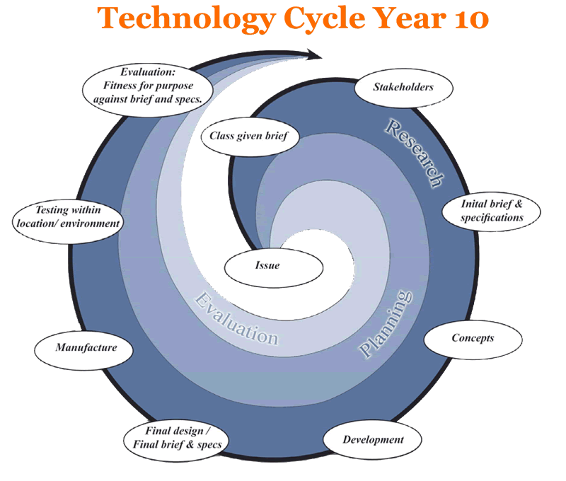
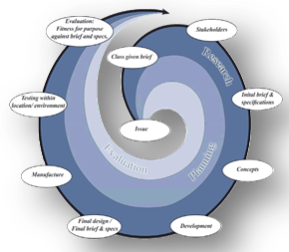 | Teaching and Learning Experiences  (bullet point list of experiences) | Learning Outcomes  (Assessment Focus)
 | Introduction  Revision and recap on previous learning about systems.  - What is a system?  - Why do we have/need systems?  - What types of systems are there? E.g. natural, technological etc.  - What is an input, output and transformation?  - Do we have any questions about systems?  - Re-read Sneetches and use the resource from Paul to guide discussion around systems.  Research –  Exploring electronic systems.  - What are they?  - When do we use them?  - Look at a torch – take apart and discuss the components – inputs, outputs etc  - Hands on with brainbox creating a simple system.  - What are the components? Bulb, wire, switch and battery.  - Make a simple light circuit with bulbs and batteries.  Discuss the inputs, outputs and controlled transformations.  Brief and Specifications  - Discuss what lighting children use at night?  - Link in with sustainability and using less electricity.  - How do you make a simple electronic circuit?  - Develop a brief together as a class.  - Develop specifications as a class.  Planning –  - children to come up with design ideas/concepts.  - Question – what are night lights? Why do we need them? What components are in them, what materials?  - Look at some examples both commercial and some others made by older students.  - Use play dough to make a model and use coloured pegs to mark where LED’s are going  - Draw the birds eye view and side view  - Annotate on the plan so that we know what colours children want  Developing a model -  - Children make a model out of clay  - Use vacuum former to make the nightlight  - Trace and cut a base using corflute  - Paint their nightlights with quality paints (dulux)  - Stations set up in class for this. Need 1 adult per station  - Children assemble as much of their circuit as they can – split pins and solder the battery casing on.  - Adults may need to help with some soldering  Final Stages –  - Apply second coat of paint and then add vivid details  - Cut out battery slot on base corflute and mark where circuit is going  - Drill holes for LED lights – children should be able to do with adult support  - Assembly – adult and child work together using glue gun. Children can put in LED’s and keep checking that that circuit is working  Evaluation –  - Evaluate their night light against specifications  - Can children explain the system they have created with reference to input, output and transformation?  - Evaluation sheet – children to put the photos of the different stages and describe what happens at each stage. | Students will:  TP  communicate the outcome to be produced  TK  • identify the components of a technological system and how they are connected  • identify the input/s and output/s of particular technological systems  • Identify that a system transforms an input to an output.  NoT  identify technological outcomes in a group of technological and non- technological objects and systems
Key Resources
Angela Miller – lecturer at University of Otago College of Education was able to support me in my teaching and own professional understanding for this unit.
Brain box – 9 kits borrowed from UOCE
Circuits
Thinking Strategy/Tool

E-Learning Tools
Class wiki with circuit links http://love2learnnz.wikispaces.com/inquiry2013

Te Reo/Tikanga

Community Links

